**Project Design Phase-II**

**Data Flow Diagram & User Stories**

|  |  |
| --- | --- |
| Date | 18 April 2025 |
| Team ID | SWTID1743603827 |
| Project Name | Book - Store |
| Maximum Marks | 4 Marks |

**Data Flow Diagrams:**

A Data Flow Diagram (DFD) is a traditional visual representation of the information flows within a system. A neat and clear DFD can depict the right amount of the system requirement graphically. It shows how data enters and leaves the system, what changes the information, and where data is stored.

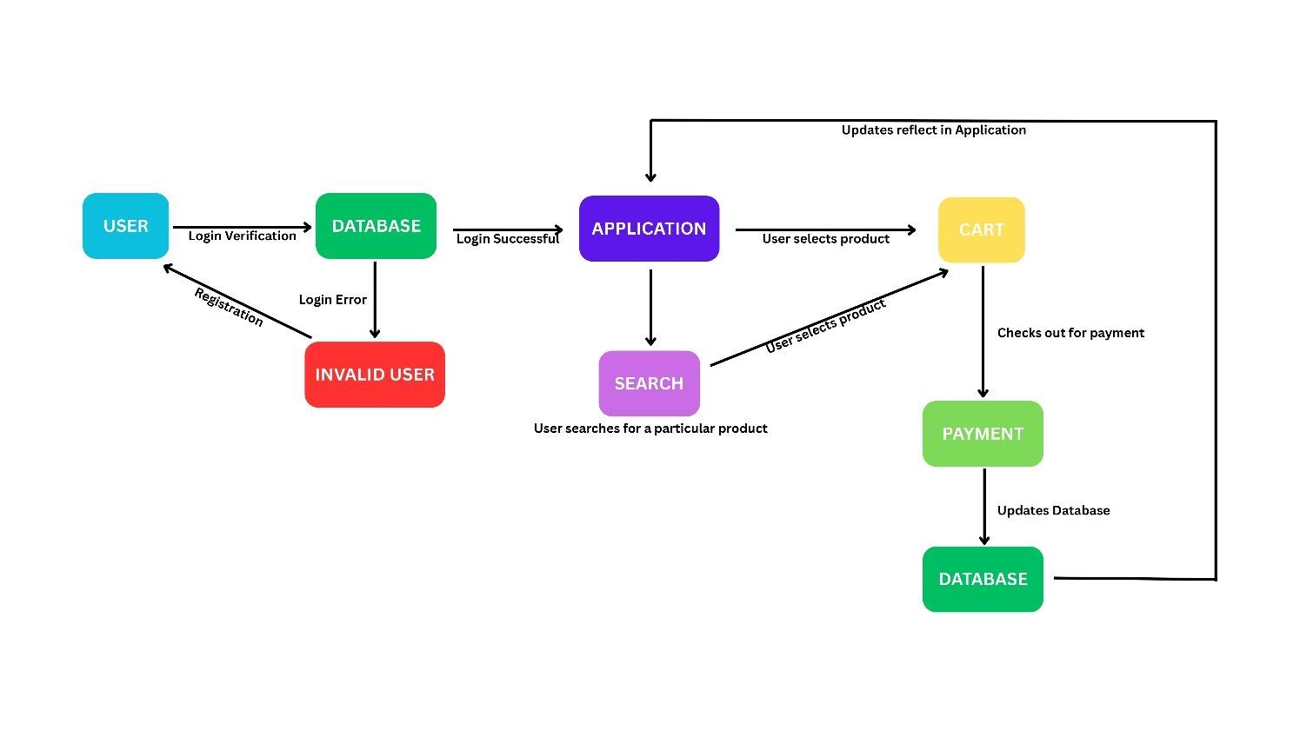

**User Stories**

|  |  |  |  |  |  |  |
| --- | --- | --- | --- | --- | --- | --- |
| **User Type** | **Functional**  **Requirement**  **(Epic)** | **User Story**  **Number** | **User Story / Task** | **Acceptance criteria** | **Priority** | **Release** |
| Customer  (Mobile user) | Product Search | USN-1 | As a user, I can search for a product using a keyword or category | I can view products matching my search | High | Sprint-1 |
| Customer  (Mobile user) | Product Selection | USN-2 | As a user, I can select a product to view its details | Product details page opens after selection | High | Sprint-1 |
| Customer  (Mobile user) | Cart Management | USN-3 | As a user, I can add selected products to my cart | Cart updates and shows selected items | High | Sprint-1 |
| Customer  (Mobile user) | Cart Management | USN-4 | As a user, I can remove products from my cart | Cart updates and removes the selected product | Medium | Sprint-2 |
| Customer  (Mobile user) | Checkout and Payment | USN-5 | As a user, I can checkout and proceed to payment from the cart | I can see a payment page and make the payment | High | Sprint-2 |
| Customer (Web user) | Product Search | USN-6 | As a web user, I can search for and select products like a mobile user | I can view and select product from search results | High | Sprint-2 |
| Customer Care  Executive | Order Lookup | USN-7 | As a support agent, I can view order details by searching using order ID | I can access order details using order ID | Medium | Sprint-3 |
| Administrator | Application Monitoring | USN-8 | As an admin, I can view real-time order and payment updates from users | Dashboard shows updated database entries | High | Sprint-3 |
| Administrator | User  Management | USN-9 | As an admin, I can deactivate invalid or suspicious users | Users marked inactive cannot log in | Medium | Sprint-3 |